ASSIGNMENT

QUESTION 1

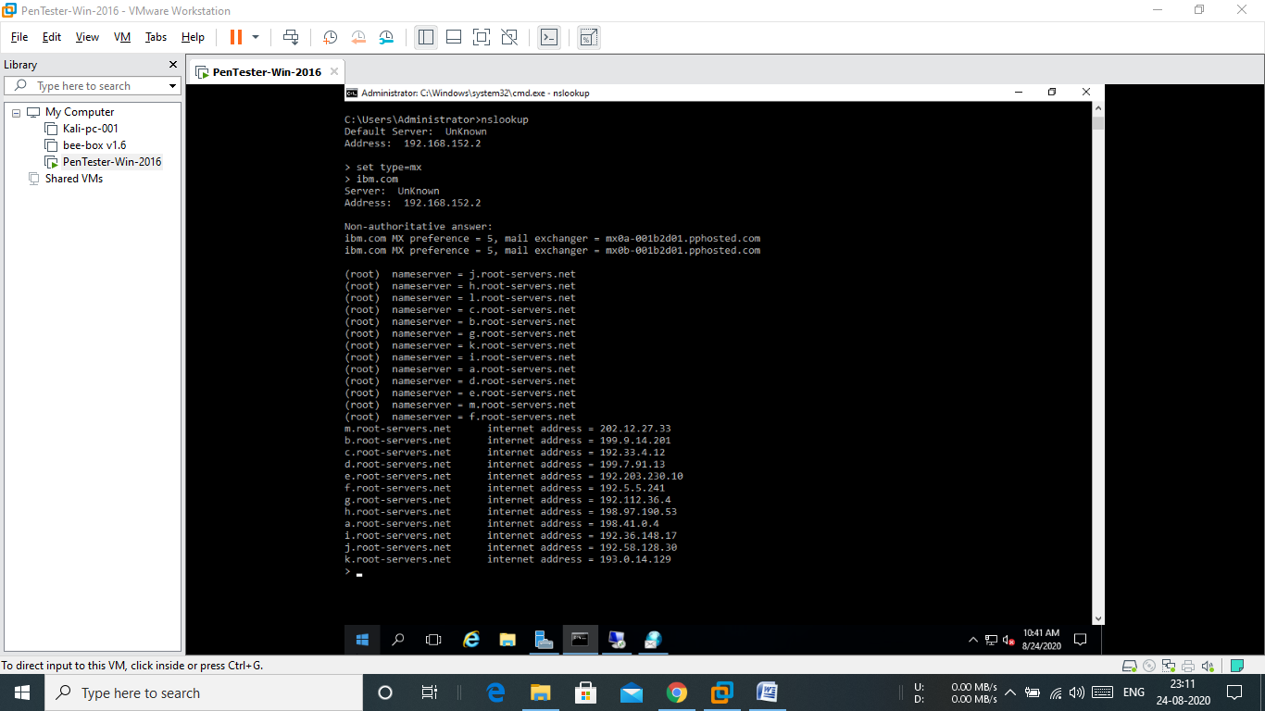

MAIL SERVERS ARE,

mx0b-001b2d01.pphosted.com

mx0a-001b2d01.pphosted.com

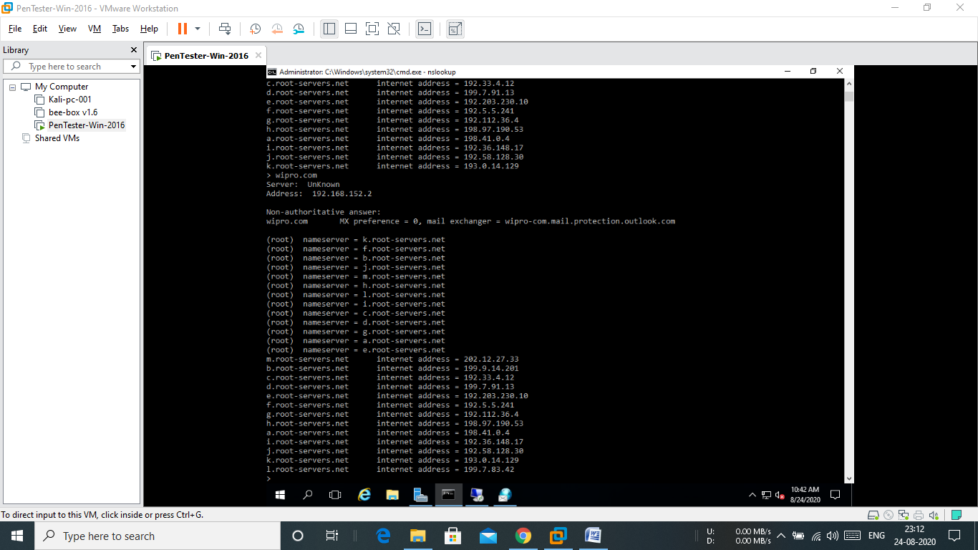

3

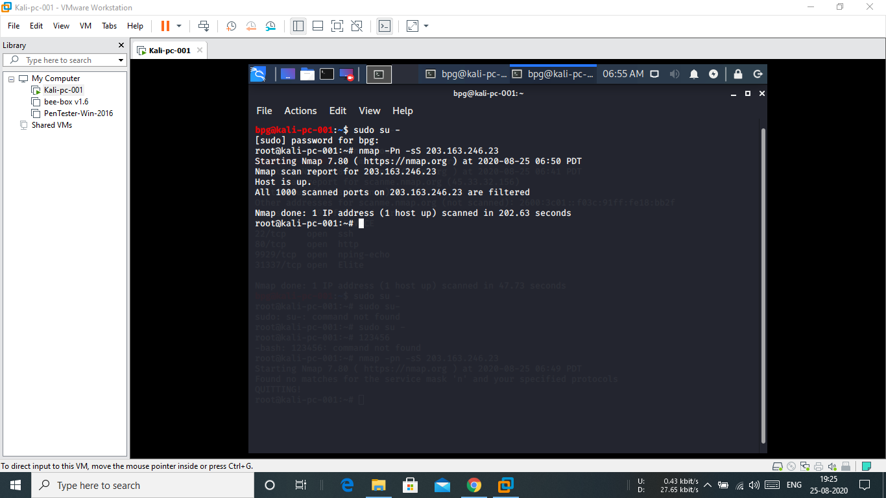

All ports are filtered. All have firewall. No open ports are available.